1.0 Entity Relationship Diagram Documentation

1.1 Introduction
The Point of Sale (POS) system uses a relational database to store information about users, products, sales,payments, and receipts. The Entity Relationship Diagram (ERD) defines the database structure by identifying the entities, their attributes, primary keys, foreign keys, and relationships.
The purpose of the ERD is to ensure data consistency, reduce redundancy, and support efficient transaction processing within the POS system.

1.2 Entity Descriptions

1.2.1 User Table
The User table stores information about all system users who operate the POS system. Users are responsible for creating products, categories, processing sales, generating receipts, and recording payments.

Attributes
Field | Description
user_id | Primary key that uniquely identifies each user
name | Full name of the user
email | User email address
cashier | Indicates the user's role
password | Encrypted user password
created_at | Date and time the user account was created

1.2.2 Category Table
The Category table stores product categories.
Each category is created by a registered user.

Attributes

Field | Description
category_id | Primary key
name | Category name
created_at | Date created
created_by_user_id | Foreign key referencing User

1.2.3 Product Table
The Product table stores all products available for sale.
Each product belongs to one category and is created by one user.

Attributes
Field | Description
product_id | Primary key
name | Product name
barcode | Unique barcode
price | Selling price
stock_quantity | Quantity available
category_id | Foreign key referencing Category
created_by_user_id | Foreign key referencing User
created_at | Date created

1.2.4 Customer Table
The Customer table stores customer information.
A customer record is optional because sales may be made without recording customer details.

Attributes
Field | Description
customer_id | Primary key
name | Customer name
phone | Customer phone number
created_at | Date customer was registered

1.2.5 Sale Table
The Sale table records every sales transaction.
Each sale is handled by one cashier and may optionally be linked to a customer.

Attributes
Field | Description
sale_id | Primary key
handled_by_user_id | Foreign key referencing User
customer_id | Foreign key referencing Customer
status | Sale status (Open, Paid, Cancelled)
total_amount | Total sale amount
created_at | Date of sale

1.2.6 SaleItem Table
The SaleItem table stores the individual products sold within a sale.
This resolves the many-to-many relationship between Sales and Products.

Attributes
Field | Description
sale_item_id | Primary key
sale_id | Foreign key referencing Sale
product_id | Foreign key referencing Product
quantity | Number of units sold
unit_price | Price per unit
subtotal | Quantity × Unit Price
added_by_user_id | Foreign key referencing User

1.2.7 Payment Table
The Payment table records payments made for sales.

Attributes

Field | Description
payment_id | Primary key
sale_id | Foreign key referencing Sale
amount | Amount paid
payment_method | Cash, Mobile Money, Card, etc.
payment_status | Payment status
processed_by_user_id | Foreign key referencing User
payment_date | Date payment was processed

1.2.8 Receipt Table
The Receipt table stores receipts generated after successful payments.
Each sale has only one receipt.

Attributes
Field | Description
receipt_id | Primary key
sale_id | Foreign key referencing Sale
receipt_number | Unique receipt number
generated_at | Date generated
generated_by_user_id | Foreign key referencing User
total_amount | Total amount on receipt

1.3 Relationships Between Tables
Parent Table | Child Table | Relationship
User | Category | One user creates many categories (1:M)
User | Product | One user creates many products (1:M)
Category | Product | One category contains many products (1:M)
User | Sale | One cashier processes many sales (1:M)
Customer | Sale | One customer can have many sales (1:M)
Sale | SaleItem | One sale contains many sale items (1:M)
Product | SaleItem | One product can appear in many sale items (1:M)
Sale | Payment | One sale can have one or more payments (1:M)
Sale | Receipt | One sale has one receipt (1:1)
User | Payment | One user processes many payments (1:M)
User | Receipt | One user generates many receipts (1:M)

Introduction

The implementation roadmap outlines the planned development of the Point of Sale (POS) system. Each module is developed as a separate controller following the Model-View-Controller (MVC) architecture provided by the CodeIgniter 4 framework. Before implementing each controller, the corresponding user interface will first be designed using Figma to establish the screen layout and user interactions. After the interface design is completed, the controller methods, models, and views will be implemented.

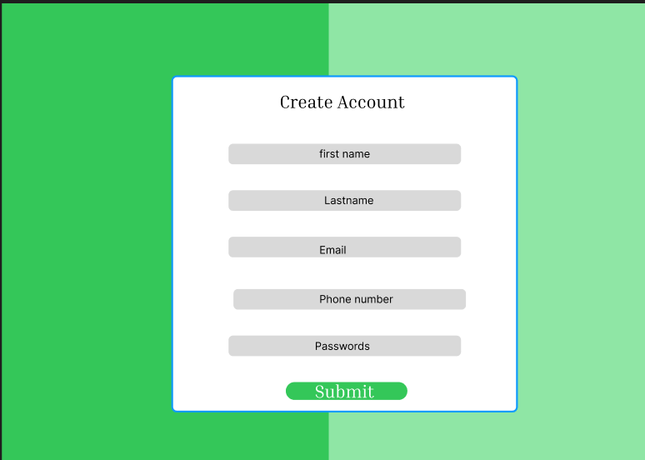

User Registration Module
Overview

The User Registration Module is responsible for creating new user accounts that can access the Point of Sale (POS) system. This module ensures that only valid user information is stored in the database by performing input validation, checking for duplicate user records, and securely encrypting user passwords before saving them.

The module is implemented using the CreateAccount Controller, which communicates with the User Model to store user information in the User table.

Controller
CreateAccount.php: Methods Implemented
1. user_page()
Displays the user registration page where administrators can create a new user account.

Process
- Receives a request to open the registration page. localhost:8080/create-account
B) Loads the registration view (create-accountpage).
C) Displays the registration form to the user.

- user_registration()
Processes the registration form and creates a new user account.

- Receives the submitted registration form.

- Validates the required fields:
- First Name
- Last Name
- Phone number
- Email Address
- Password
Area affected

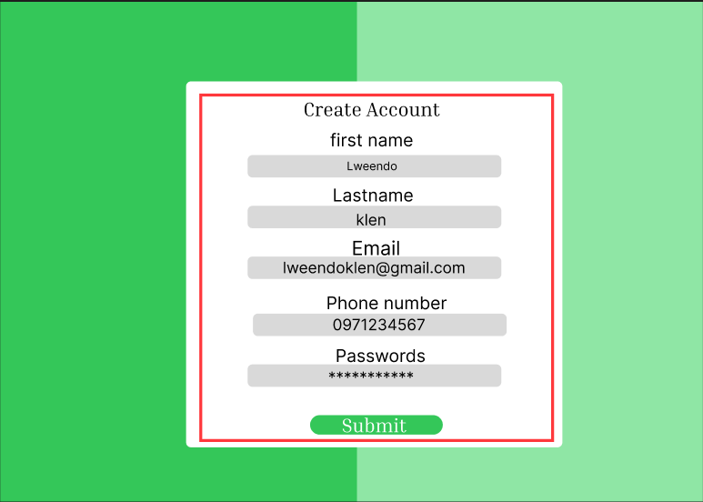

(iv) Returns validation errors if any required field is missing or the email format is invalid.

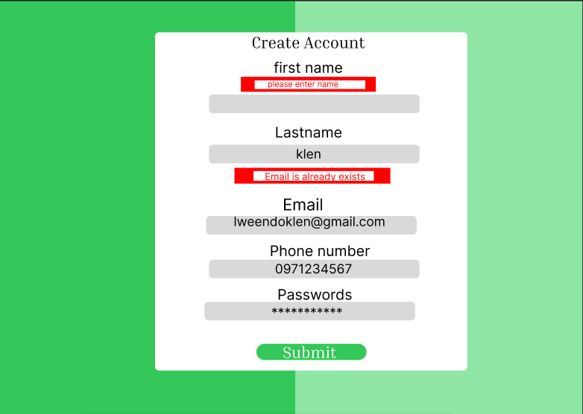

- Sanitizes the user's input to prevent malicious data from being stored.
- Generates a username automatically by combining the first name and last name in lowercase format.
- Encrypts the user's password using PHP's password_hash() function before storing it in the database.
- Checks whether the supplied email address already exists.
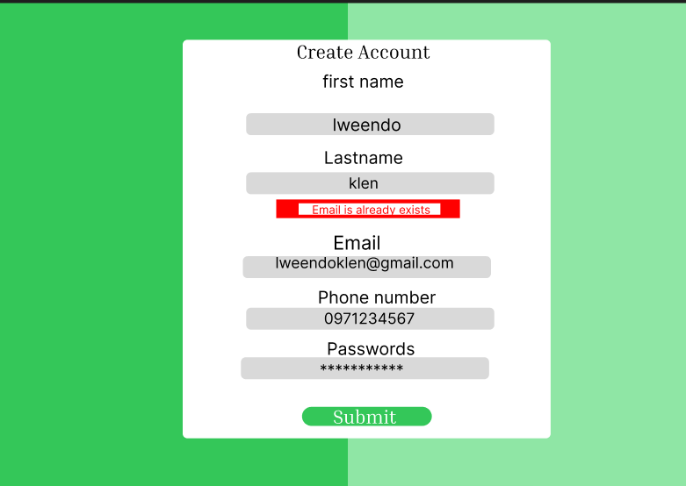

Inserts the new user record into the User table if all validation checks are successful.

Redirects the user to the login page( localhost:8080/userlogin) with a success message.(User Account created)

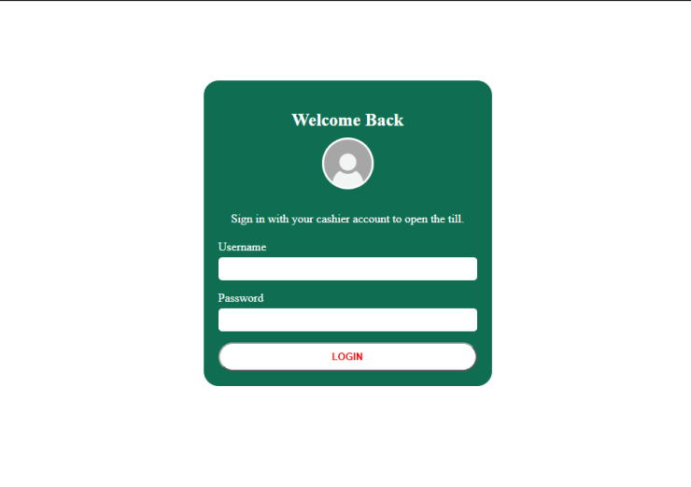

Validation Rules
The registration module currently validates the following fields before creating an account:\
Field | Validation Rule
First Name | Required
Last Name | Required
Email | Required, Valid Email Format
Password | Required

Database Interaction
The registration process interacts with the User table.

Data Stored
Field | Description
firstname | User's first name
lastname | User's last name
username | Automatically generated username
password | Encrypted password
email | User email address

Security Features
The registration module includes the following security measures:

- Input sanitization using CodeIgniter request filtering.
- Password encryption using PHP's password_hash() function.
- Duplicate email address detection.
- Server-side input validation before inserting data into the database.

User Authentication Module

Overview

The User Authentication Module is responsible for verifying the identity of registered users before granting access to the Point of Sale (POS) system. The module validates user credentials, creates a secure session for authenticated users, and restricts unauthorized access to protected system resources.

The module is implemented using the AuthController, which interacts with the UserModel to retrieve user information stored in the User table.

Controller

AuthController.php :Methods Implemented
- loginPage()
Authenticates registered users and grants access to the POS system.
Process
1)Receives the submitted username and password.
2)Removes leading and trailing spaces from the username.
3)Removes any additional white spaces within the username.
4)Validates that both the username and password fields are provided.
5)Retrieves the corresponding user record from the database using the entered username.
6) Verifies the entered password against the encrypted password stored in the database
7) using PHP's password_verify() function.
8) Creates a user session if authentication is successful.
9) Stores the following session information:
User ID
Username
User Role
- Login Status
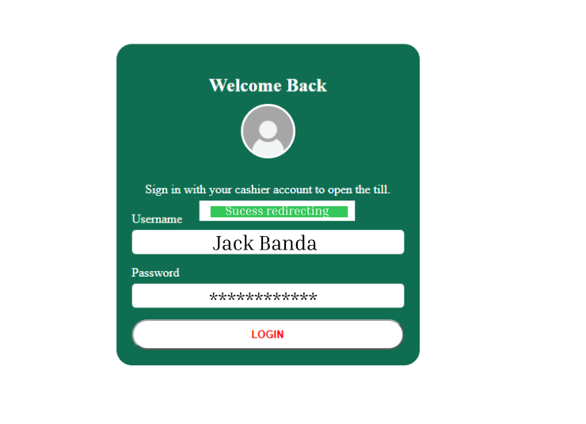
- Checks the user's role.

- Redirects to http://localhost:8080/index.php/DashBoard/index users with the Cashier role to the Dashboard.

- Displays an Invalid Credentials message if authentication fails.
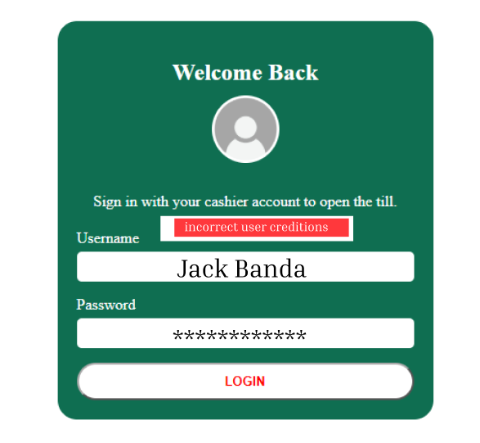

3. logout()
Purpose
Terminates the current user session and securely logs the user out of the system.
Process
- Destroys the active session

- Removes all stored session data.
3)Redirects the user to the login page.
4)Displays a successful logout message.

Validation Rules
The login module validates the following fields before attempting authentication.
Field | Validation Rule
Username | Required
Password | Required

Session Management
After successful authentication, the system creates a session containing the following information.
Session Variable | Description
user_id | Unique identifier of the logged-in user
username | Username of the authenticated user
role | User role (e.g., Cashier)
logged_in | Indicates whether the user has successfully logged into the system
The session is used to control access to protected pages such as the Dashboard.

Security Features
The authentication module implements several security measures to protect user accounts and system resources.
Server-side validation of login credentials.
Removal of unnecessary whitespace from usernames before authentication.
Password verification using PHP's password_verify() function.
Secure session creation after successful authentication.
Prevention of unauthorized dashboard access through session validation. Session destruction during user logout.

Database Interaction
The authentication process interacts with the User table to retrieve user information.

Data Retrieved
Field | Purpose
user_id | Creates the user session
username | Identifies the authenticated user
password | Used for password verification
role | Determines the user's access level

Dashboard Module

Overview
The Dashboard Module serves as the main landing page of the Point of Sale (POS) system after a user has successfully logged in. It provides a summary of the system's current operational status by displaying key business statistics and recent sales activities. The dashboard retrieves information from multiple database tables, including Sales, Products, and Categories to provide users with an overview of daily business operations.
The module is implemented using the DashBoard Controller, which communicates with the corresponding models to retrieve and display the required information.

Controller
DashBoard.php: Methods Implemented

1. index()
Purpose
Displays the main dashboard by retrieving summary statistics, recent sales transactions, and products with low stock levels.

Process Flow
The dashboard performs the following operations when a user accesses the page:
- Checks whether the user has an active login session.
- Redirects unauthenticated users to the login page http://localhost:8080/userlogin if the session has expired.
- Retrieves the logged-in user's username and role from the current session.
- Retrieves the 50 most recent sales transactions.
Area affected

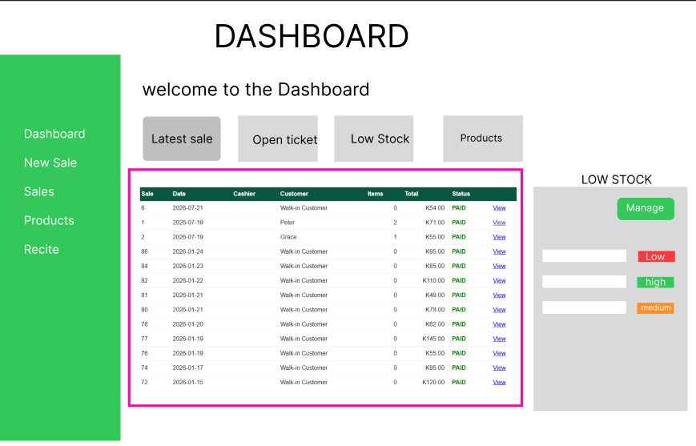
Calculates the total number of sales made on the current day.
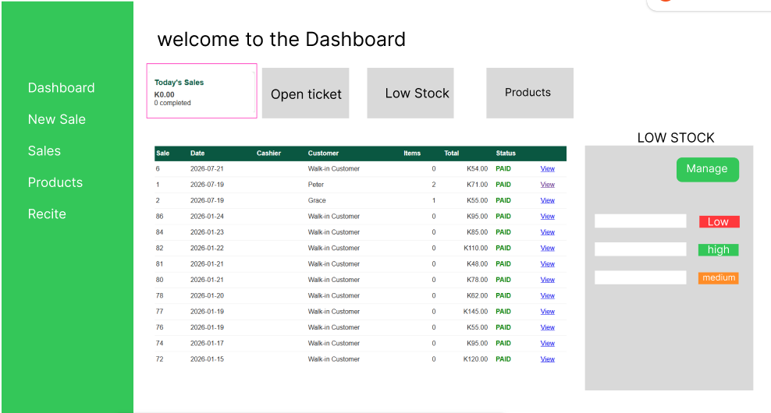

- Calculates today's total sales revenue.
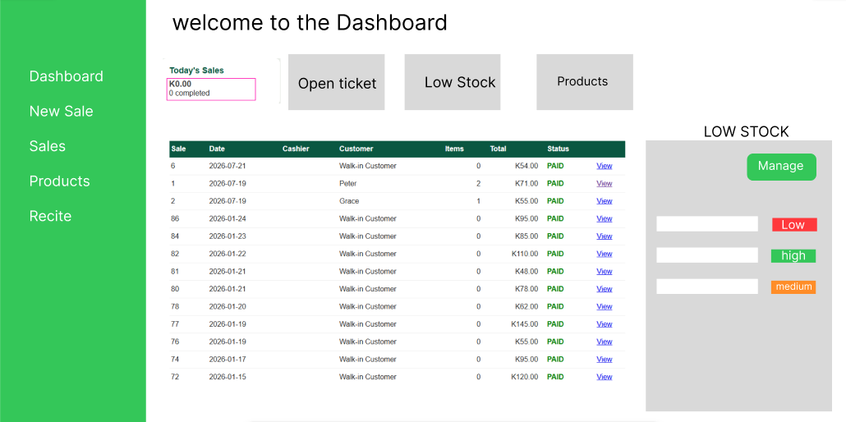

- Counts all sales whose status is OPEN.

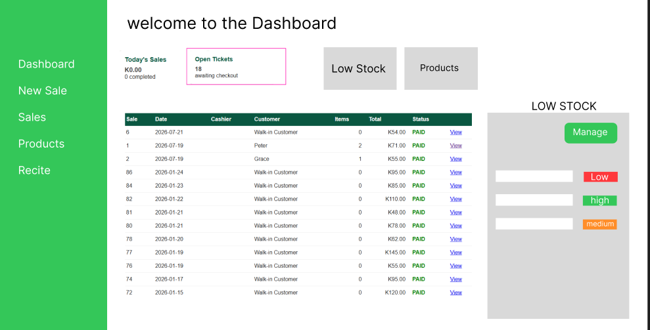

Counts the total number of registered products.
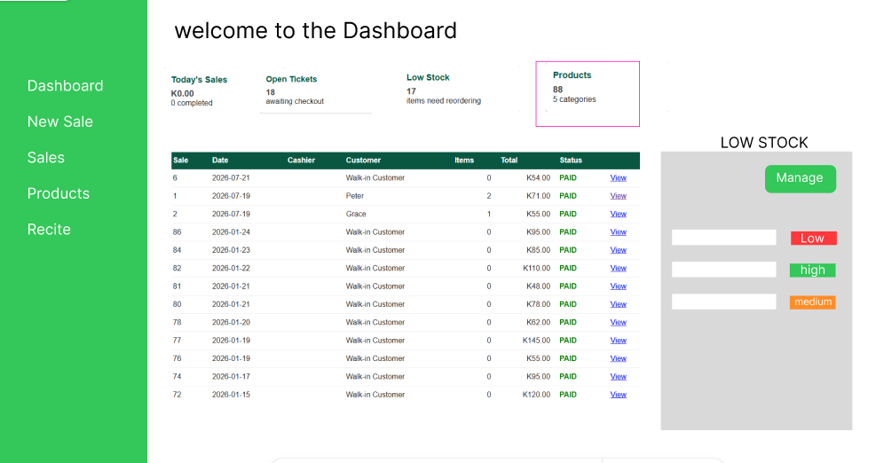
- Counts the number of products currently classified as low stock.

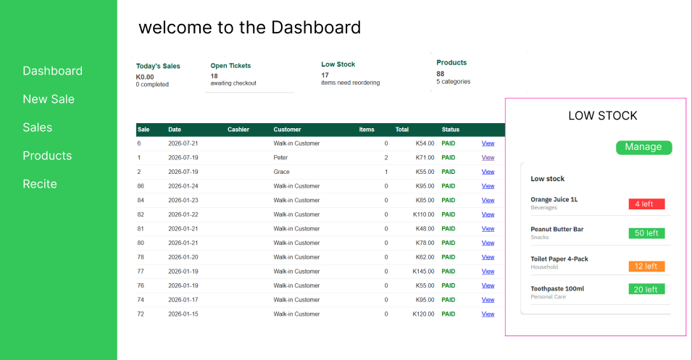

8.Packages the retrieved information and sends it to the dashboard view for display.

Dashboard Summary Cards
The dashboard currently displays the following summary information.
Dashboard Item | Description
Today's Sales | Displays the total revenue generated from sales made on the current date.
Today's Sales Count | Displays the total number of sales transactions completed today.
Open Tickets | Displays the number of sales currently marked with the OPEN status.
Low Stock Count | Displays the total number of products whose stock quantity is below the defined threshold.
Total Products | Displays the total number of products stored in the system.
Total Categories | Displays the total number of product categories.
Total Customers | Displays the total number of registered customers.

Recent Sales
The dashboard retrieves and displays the ten most recent sales transactions using the getSales() method provided by the SaleModel.
The recent sales section enables users to quickly monitor recently completed transactions without navigating to the Sales module.

Low Stock Monitoring
The dashboard identifies products whose stock quantity is less than ten units.
For each low-stock product, the system retrieves:
Product Name
Category Name
Current Stock Quantity
The products are displayed in ascending order of stock quantity, allowing users to identify inventory items that require restocking.

Database Interaction
The dashboard retrieves information from the following database tables.
Table | Information Retrieved
User | Logged-in user's username and role
Sale | Recent sales, today's sales, open tickets, total revenue
Product | Total products and low-stock products
Category | Category names and total category count

Models Used
The Dashboard Controller currently interacts with the following models:
SaleModel
ProductModel
CategoryModel
These models retrieve the data required to generate the dashboard summary and display current business information.

New Sale Module

Overview
The New Sale Module is responsible for initiating a new sales transaction within the Point of Sale (POS) system. It allows the cashier to browse available products, search and filter products, add products to a temporary shopping cart, modify cart contents, and submit the cart for processing.
The module is implemented using the Newsales Controller, which interacts with the Product, Category, and Cart models. During a sales transaction, selected products are temporarily stored in a session-based shopping cart before being saved to the database during checkout.

Controller

Newsales.php

1. Newsale()
Purpose
Displays the New Sale page and loads all products available for sale.
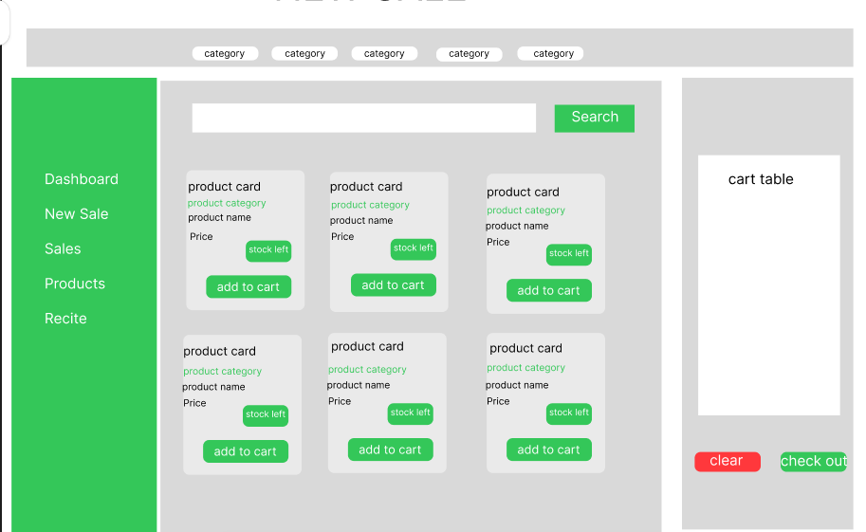

Process
- Verifies that the user has an active login session.
- Retrieves the logged-in user's information.
- Retrieves available products together with their categories.
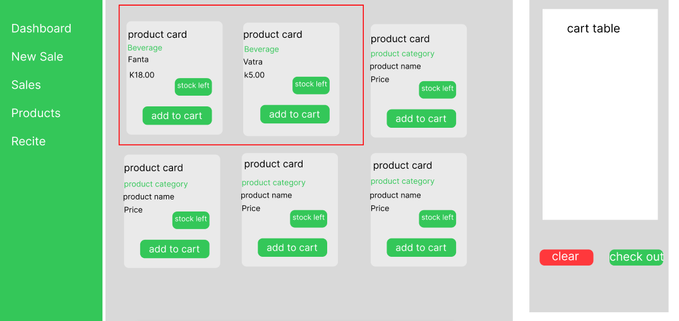
- Retrieves the current shopping cart stored in the user's session.
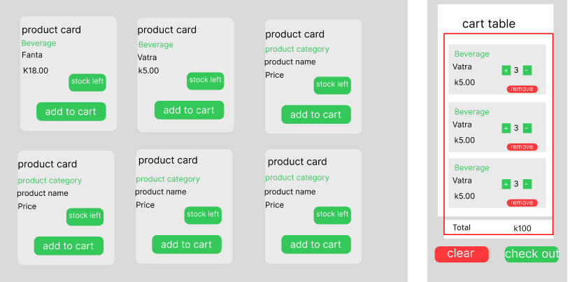

- Displays the New Sale interface.
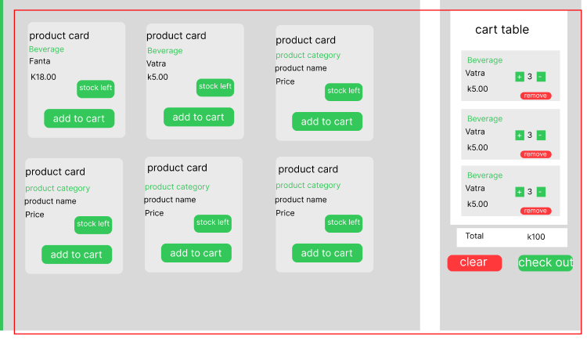

Information Displayed
- Product Name
- Category
- Unit Price
- Available Stock
- Current Shopping Cart

2. search_product()
Purpose
Searches products by product name.

Process
- Receives the product name entered by the cashier.
- Searches the Product table for matching products.
- Retrieves matching product information.
- Displays the filtered product list while maintaining the current shopping cart.
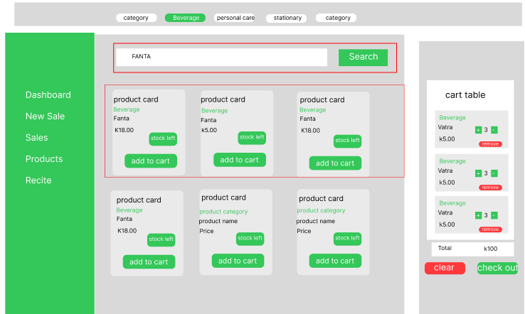

3. display_products()
Purpose
Displays products based on the selected category.

Process
- Receives the selected product category.
- Retrieves products belonging to the selected category.
- Displays all products when the ALL option is selected.
- Preserves the current shopping cart during filtering.

4. cart()
Purpose
Adds a selected product to the shopping cart.

Process
- Receives the selected product details.
- Checks whether the product already exists in the shopping cart.
- Increases the product quantity if it already exists.
- Calculates the subtotal for the selected product.
- Adds new products to the session cart.
- Updates the shopping cart stored in the user's session.

5. update_qty()
Purpose
Updates the quantity of a selected product within the shopping cart.

Process
- Receives the selected product.
- Increases or decreases the product quantity.
- Prevents quantities from falling below one.
- Recalculates the product subtotal.
- Updates the shopping cart.

6. view()
Purpose
Displays the current contents of the shopping cart.

Process
- Retrieves all products currently stored in the session cart.
- Displays the shopping cart to the cashier.

7. remove()
Purpose
Removes a selected product from the shopping cart.

Process
- Receives the selected product identifier.
- Removes the product from the shopping cart.
- Reindexes the remaining cart items.
- Updates the session cart.

8. clear()
Purpose
Removes all products from the shopping cart.

Process
- Deletes the shopping cart stored in the current session.
- Returns the user to the New Sale page with an empty cart.

9. checkout()
Purpose
Processes the shopping cart by storing its contents in the Cart table.

Process
- Retrieves all products stored in the session cart.
- Validates that the cart is not empty.
- Saves each cart item into the Cart table.
- Records the username of the cashier who created the cart.
- Clears the session cart after successful processing.
- Displays a successful checkout message.
Note: At the current stage of development, the checkout process stores cart items in the Cart table only. The creation of Sale, SaleItem, Payment, and Receipt records will be implemented in subsequent development phases.

Database Interaction
The New Sale Module currently interacts with the following database tables.
Table | Purpose
Product | Retrieves products available for sale
Category | Retrieves product category information
Cart | Stores selected cart items during checkout

Models Used
The Newsales Controller currently interacts with the following models:
- ProductModel
- CategoryModel
- CartModel

Features Implemented
The New Sale Module currently provides the following functionality:
- Displays products available for sale.
- Displays product categories.
- Searches products by product name.
- Filters products by category.
- Adds products to a shopping cart.
- Updates product quantities in the cart.
- Removes selected products from the cart.
- Clears the entire shopping cart.
- Stores cart items in the Cart table during checkout.
- Maintains shopping cart data using session storage.
- Restricts access to authenticated users through session validation.

Product Management Module

Overview
The Product Management Module is responsible for displaying and locating products stored within the Point of Sale (POS) system. The module allows users to view product information, search for products by name, and filter products according to their category.
The module is implemented using the ProductController, which communicates with the ProductModel and CategoryModel to retrieve product and category information from the database.

Controller
ProductController.php

1. Products()
Purpose
Loads the main product management page.
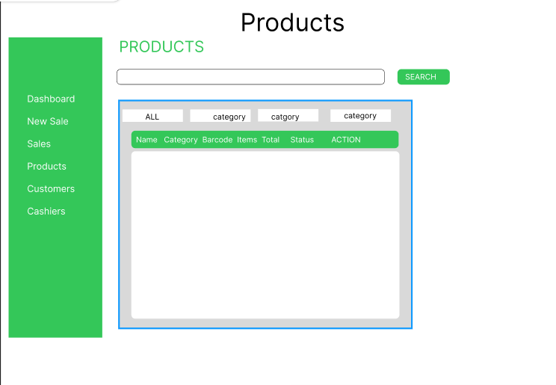

Process
- Receives a request to access the Product page.
- Loads the product view.
- Displays the product management interface.
View:
product/product

2. search_product()
Purpose
Allows the user to search for a specific product using its product name.

Process
- Receives the search term entered by the user.
- Retrieves product information from the Product table.
- Joins the Product table with the Category table.
- Searches for products matching the entered product name.
- Sorts the results according to the product creation date.
- Limits the returned results to fifty products.
- Sends the matching products to the product view.

Product Information Displayed
- Product Name
- Category
- Barcode
- Price
- Stock Quantity

3. categories_navbar()
Purpose
Allows users to filter products according to their category.

Process
- Receives the selected category from the navigation interface.
- Retrieves products together with their category information.
- Displays all products when ALL is selected.
- Filters products according to the selected category.
- Sorts the products by creation date.
- Displays the filtered product results.

Database Interaction
The Product Module interacts with the following tables:
Table | Purpose
Product | Stores and retrieves product information
Category | Provides category information used to classify products

Models Used
The Product Controller currently uses:
- ProductModel
- CategoryModel
ProductModel is responsible for retrieving product records, while CategoryModel is used to retrieve category information and perform category-based product filtering.

Current Features
The Product Module currently provides:
- Product page display.
- Product search by name.
- Product filtering by category.
- Display of product categories.
- Display of product prices.
- Display of product stock quantities.
- Display of product barcodes.
- Display of product names.

Receipt Module
Overview

The Receipt Module is responsible for displaying receipts generated from completed sales transactions. The module uses the Sale table as the primary source of transaction information and identifies sales that have been successfully completed by checking their payment status.

A receipt is generated from a sale whose status is PAID. Therefore, the Receipt Module retrieves the corresponding sale_id and its associated transaction information from the Sale table.

The module will also be connected to the SaleItem table so that the products belonging to the selected sale can be displayed on the receipt.

Receipt Selection Process
The system will retrieve sales from the Sale table and only display transactions whose status is PAID.

Process
- Retrieve sales records from the Sale table.
- Check the status of each sale.
- Select only sales with a PAID status.
- Display the paid sales as available receipts.
- Allow the user to select a particular sale.
- Retrieve the selected sale_id.
- Use the sale_id to retrieve the corresponding SaleItem records.
- Display the products and quantities belonging to the sale.
- Calculate/display the transaction total.
- Present the transaction as a receipt.

Controller

Receipt.php
The Receipt Controller will be responsible for retrieving and displaying paid sales as receipts.

Planned Methods

1. displayReceipt()
Purpose
Displays sales that have been successfully paid and are therefore eligible to be viewed as receipts.
Process
- Retrieve sales from the Sale table.
- Filter sales where status = PAID.
- Display the resulting paid transactions.
- Allow the user to select a transaction.

2. viewReceipt()
Purpose
Displays the detailed receipt for a selected paid sale.
Process
- Receive the selected sale_id.
- Retrieve the corresponding Sale record.
- Retrieve all SaleItem records associated with the sale_id.
- Retrieve the relevant product information.
- Display the complete receipt.

3. searchReceipt()
Purpose
Allows users to locate a receipt using the sale identifier.
Process
- Receive the search value.
- Search the Sale table using the sale_id.
- Only return transactions whose status is PAID.
- Display the matching receipt.

